RESUME

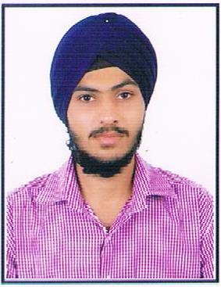  Bhupendra Singh  Contact No:  +91-8696204850  E-Mail:  bhupendrasingh7@yahoo.com  Address for Correspondence:  S/O Mr. Deedar Singh  Ram Nagar, NEB  Alwar (Rajasthan), 301001  Permanent Address:  S/O Mr. Deedar Singh  Ram nagar , NEB,  Alwar (Rajasthan), 301001  Personal Data:  Date of Birth : 19 June 1993  Father’s Name : Mr. Deedar Singh  Marital Status : Single  IT Skills:  MS Office Word 2007, MS Office Excel 2010, Window XP, Window 7.  Personal Attributes  - Positive attitude  - Strong will power  - Eager learner | Career Objective  To provide my best to the organization and attain new heights in the corporate world through hard work , utmost dedication, sincerity and organizational growth.  Professional Experience  Presently working with UNITED BREWERIES LIMITED, ALWAR as a Mechanical ENGINEER in Production Department.  Job Responsibilities: - Production & Maintenance.  Experience :- 2.5 year  - Plan, schedule and monitor material movement in production cycle to ensure continuous operations.  - Tracking Plant performance and working out ways of improving it for the department.  - Execution of production Plan & Manufacturing process carried out as per defined norms and meets quality norms in shifts.  - Method improvement & line balancing for a variety of jobs resulting in productivity improvement.  - Focusing on optimization of process parameters and initiating process improvements for achieving bottom line objectives and productivity targets.  - Production execution as per planned, raw materials handling, shift scheduling and handling etc.  - To achieve KPM of Safety, Quality, Efficiency, Productivity and Cost. Implementation of Quality systems e.g. FSMS, 5S in the shift  - Knowledge of SAP and similar systems.  Professional Qualification  - Bachelor of Technology in Mechanical with 75% from Institute of Engineering & Technology, Alwar (2011-15)  Internship  1. Organization: Eicher Engine, Alwar (A Unit Of TAFE Motors And Tractors Ltd.)  Duration : 06 June 2014 to 21 July 2014.  Tasks assigned:  - Study of single cylinder assembly.  - Power saving in administration block.  - Thermography imaging.  Workshops and Seminar  - Workshop on “CNC Machine” conducted by NIESBURD at IET, Alwar.  - Workshop on “Repair & Maintenance of Power Conditioning”, conducted by NIELIT at AIET, Alwar.  - HR Conclave on Industry Institute Interaction, Challenges and Opportunities, at IET, Alwar.  Academic Profile  - Class XII from Popular Academy Sr. Sec. School, Alwar (RBSE Board) with First Division (73%) in 2011.  - Class X from Monalisa Sec. School, Alwar (RBSE Board) with First Division (74.69%) in 2009.  Interests  - Traveling  - Listening Music  - Cooking

Date :- (Bhupendra Singh)

